WorkWebs Audio Mixing Ecosystem Tools 2-WING Configuration Documentation

V20261030a

Overview
This document covers the 2-WING solution. The CUE system is documented in another folder in this repository.
This solution provides a merged mixer utilizing 2 Behringer WING Racks. It includes snapshots for the WING racks, a Mixing Station setup file for mixing with this setup on the WING racks, a REAPER file to record and playback all the tracks from the 2 WINGS, a VB-Audio Matrix Coconut configuration to use to create a virtual multichannel device from the feeds from the 2 WINGS, a Mixing Station file for use on an additional computer to remote monitor and solo the channels of 1 WING rack for troubleshooting mics by an additional technician, and also includes linkage and configuration to ad additional Behringer X32 to interface to for AES50 transfer of feeds to the X32 (in case the site already has an X32 connected to some inputs and the outputs for the site so you can plug and play without rewiring those items).

Hardware
All items mentioned below connect by Wired Network links to a single router dedicated to this solution (plus possibly an additional switch connected to that router if the router does not provide sufficient connectivity).
There are 2 touchscreens used for mixing, one for each mixer. Each of them connects to their own Windows PC. Each of those PCs runs an instance of Mixing Station. Keeping them separate prevents Windows Focus conflicts when working with both Touch Screens simultaneously.
There is one Windows PC that runs REAPER and VB-Audio Matrix Coconut and 2 sessions of WING Edit. This computer will record and replay the tracks tied to the WINGS. It also is connected to a 4K monitor that displays the 2 WING edit sessions. A Laptop is recommended so the REAPER and VB-Audio Matrix Coconut session can be on the laptop screen. MultiPlay is also run on this computer to play audio tracks as needed for the session. MultiPlay is connected to a WING via a Peavey USB-P and XLR cables if desired. (MultiPlay can be triggered using the CUE system in the WorkWebs solution if desired). The connections from the WINGs to this PC are via USB. Each interface’s driver can only be used once so one WING feeds via a DN9630 and the other by the WING USB driver. (An X-32 also can feed in via the X-USB driver.) The VB Audio Matrix Coconut takes all of these drivers as sources and combines them to a single virtual audio device that REAPER connects to. Mouse Without Borders also allows sharing of a mouse across the 2 laptops making it less cumbersome if you desire a mouse with them. It can even allow one mouse for all 3 laptops if you configure it that way.
If using the CUE system as well, a Companion configuration is provided for numbered CUE management. The CUE script and VICREO Listener and Companion instances can all run together on one other PC for remote cue control. One of the PCs running a WING’s Mixing Station instances can also run a browser session that opens the Companion linkage.
There are also, of course, 2 Behringer WINGs.
There is an option to use an external hardware device on the Vocal BUS and likewise on the Instrument BUS.
In the sample configuration, 1 WING is primarily for vocals, the other for instruments, but that separation is not required but does keep things easier to manage.
Another Mixing Station configuration and laptop running Linux Mint provides for an assistant located in another location of the space to monitor (solo) and see levels for 1 WING. This helps in troubleshooting and is especially backstage for fixing headworn mic issues. The SOLO out is sent out via AES50 to an onstage position or direct from XLR outs to get to the monitoring person. An additional old analogue mixer can fed the output from the stagebox if desired and phones attached there.be used for that function.

The WINGS
The configuration calls for 2 WING Racks. We will call them WING1 and WING2 for reference.
WING1 has outputs for the Main Left, Right, Subs, and Center (mono) feeds as well as handles the Talkback input. It also includes as-configured 4 outputs and 4 inputs to go to and from external hardware for the Vocal and Instrument Buses.
WING2 has outputs for the 6 configured mono monitor feeds.
AES50 C is used to share information between the 2 WINGs. Reverbs for Instruments and Vocals from both WINGs are applied on WING1, along with merged final processing on the main feeds. WING2 handles the monitor items in a merged manner.
Solo from WING1 feeds to WING2 and is exposed on a channel on WING2. This allows the headphone and outputs on WING2 to be used to merge SOLO output from both WINGs into one combined path.

Setup Photos
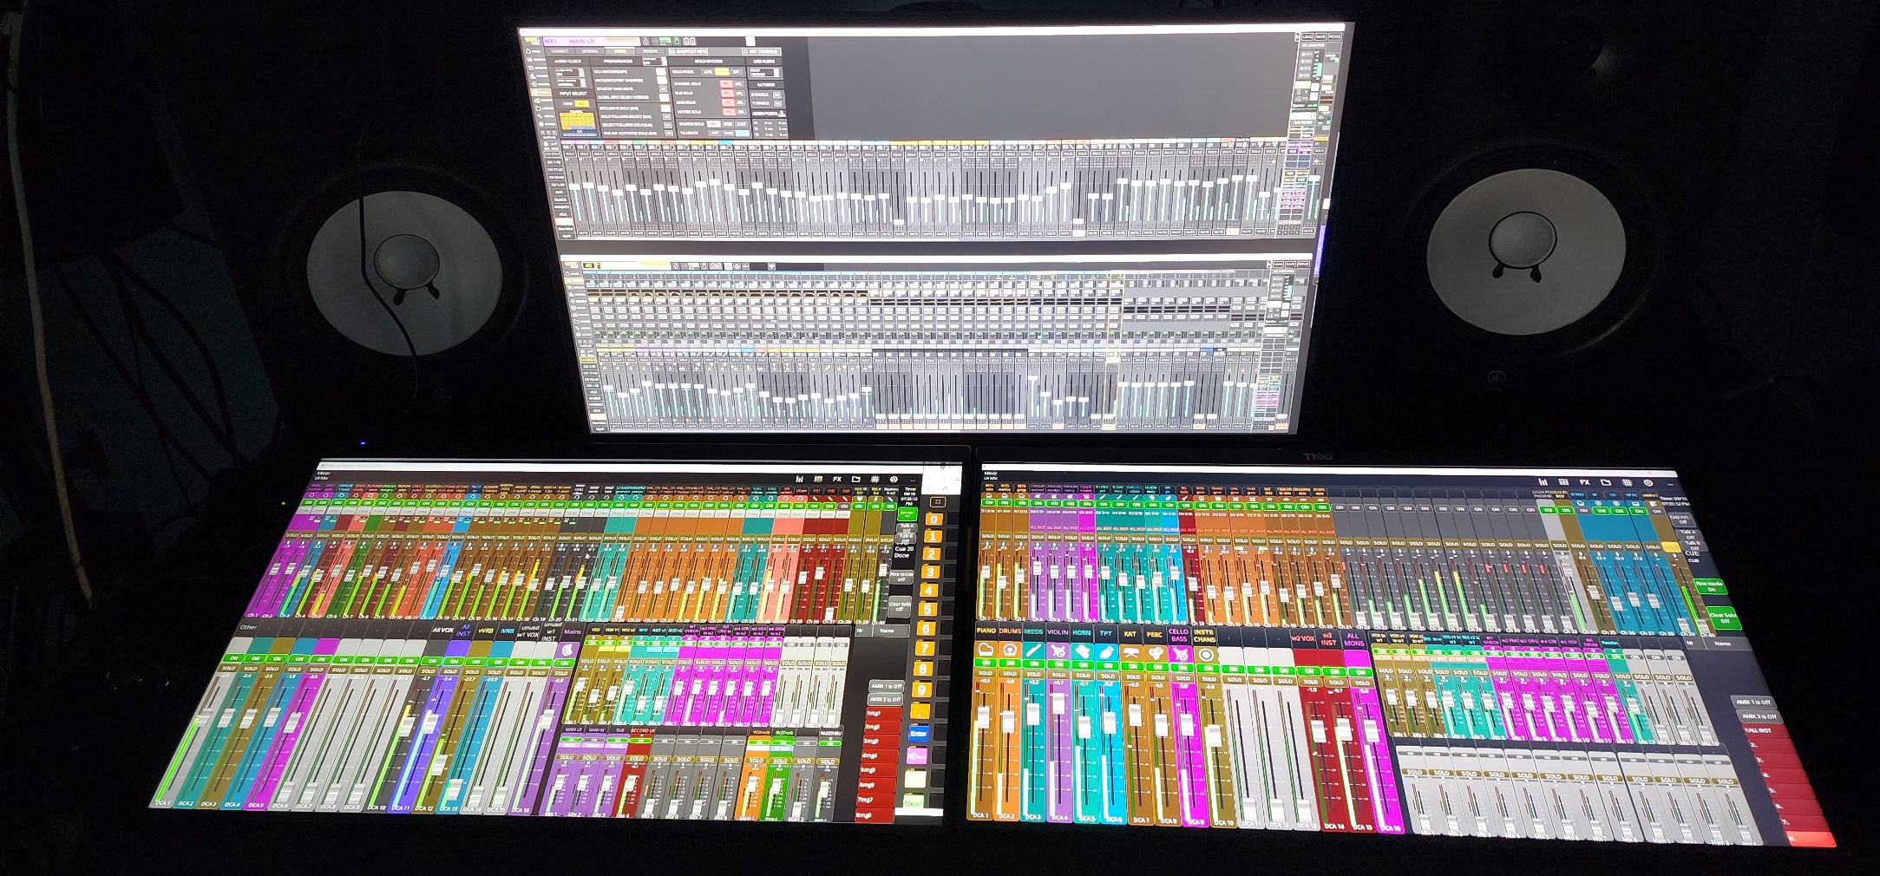
1 The top screen shows 2 WING EDIT sessions, one for each WING. The lower left shows WING1 with Mixing Station and a browser to the CUE system via Companion and Vicreo Listener, and the lower right the Mixing Station setup for WING2. Mouse Without Borders allows 1 mouse to operate across both of these computers. (note that the mixing station layout may have been updated since this photo was taken)
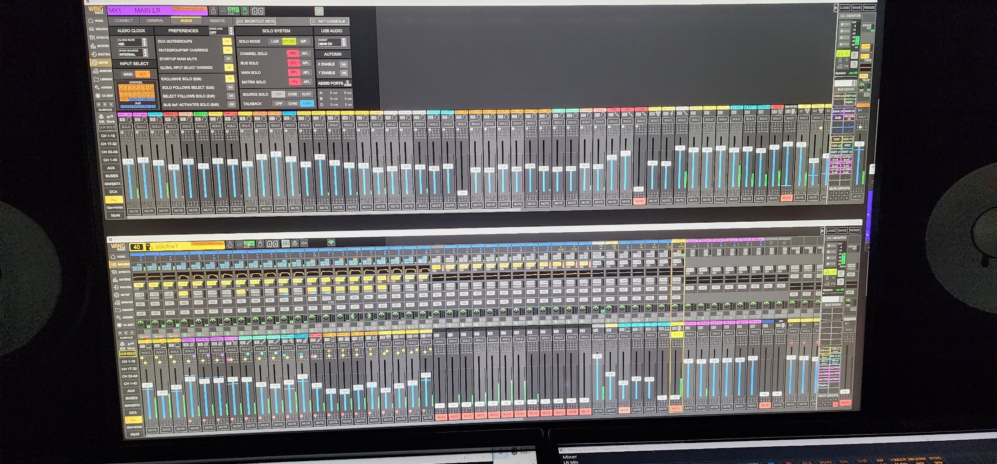
2 This image is just the top monitor of the prior image with a WING EDIT session for each WING.
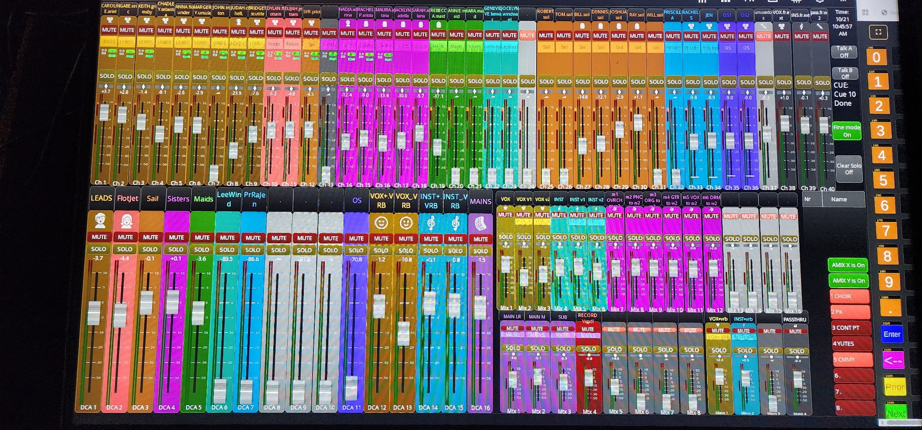
3 This is the WING1 Mixing Station view and the browser session for CUEs. There are 37 open channels. The last 3 of the 40 are the return from the external hardware for Vocals and the return from external hardware for INSTRUMENTS and then lastly a passthrough channel for passthrough from WING2 for content that should not process through the Vocal or Instrument busses or the external hardware. . (note that the mixing station layout may have been updated since this photo was taken)

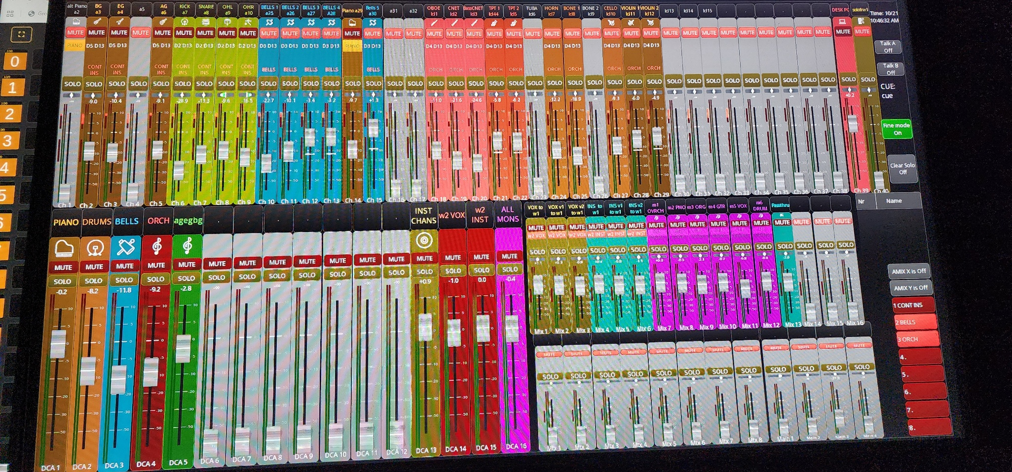
4 This is the WING2 Mixing Station view. There are 39 available channels with channel 40 being the SOLO coming into WING2 from WING1. . (note that the mixing station layout may have been updated since this photo was taken)

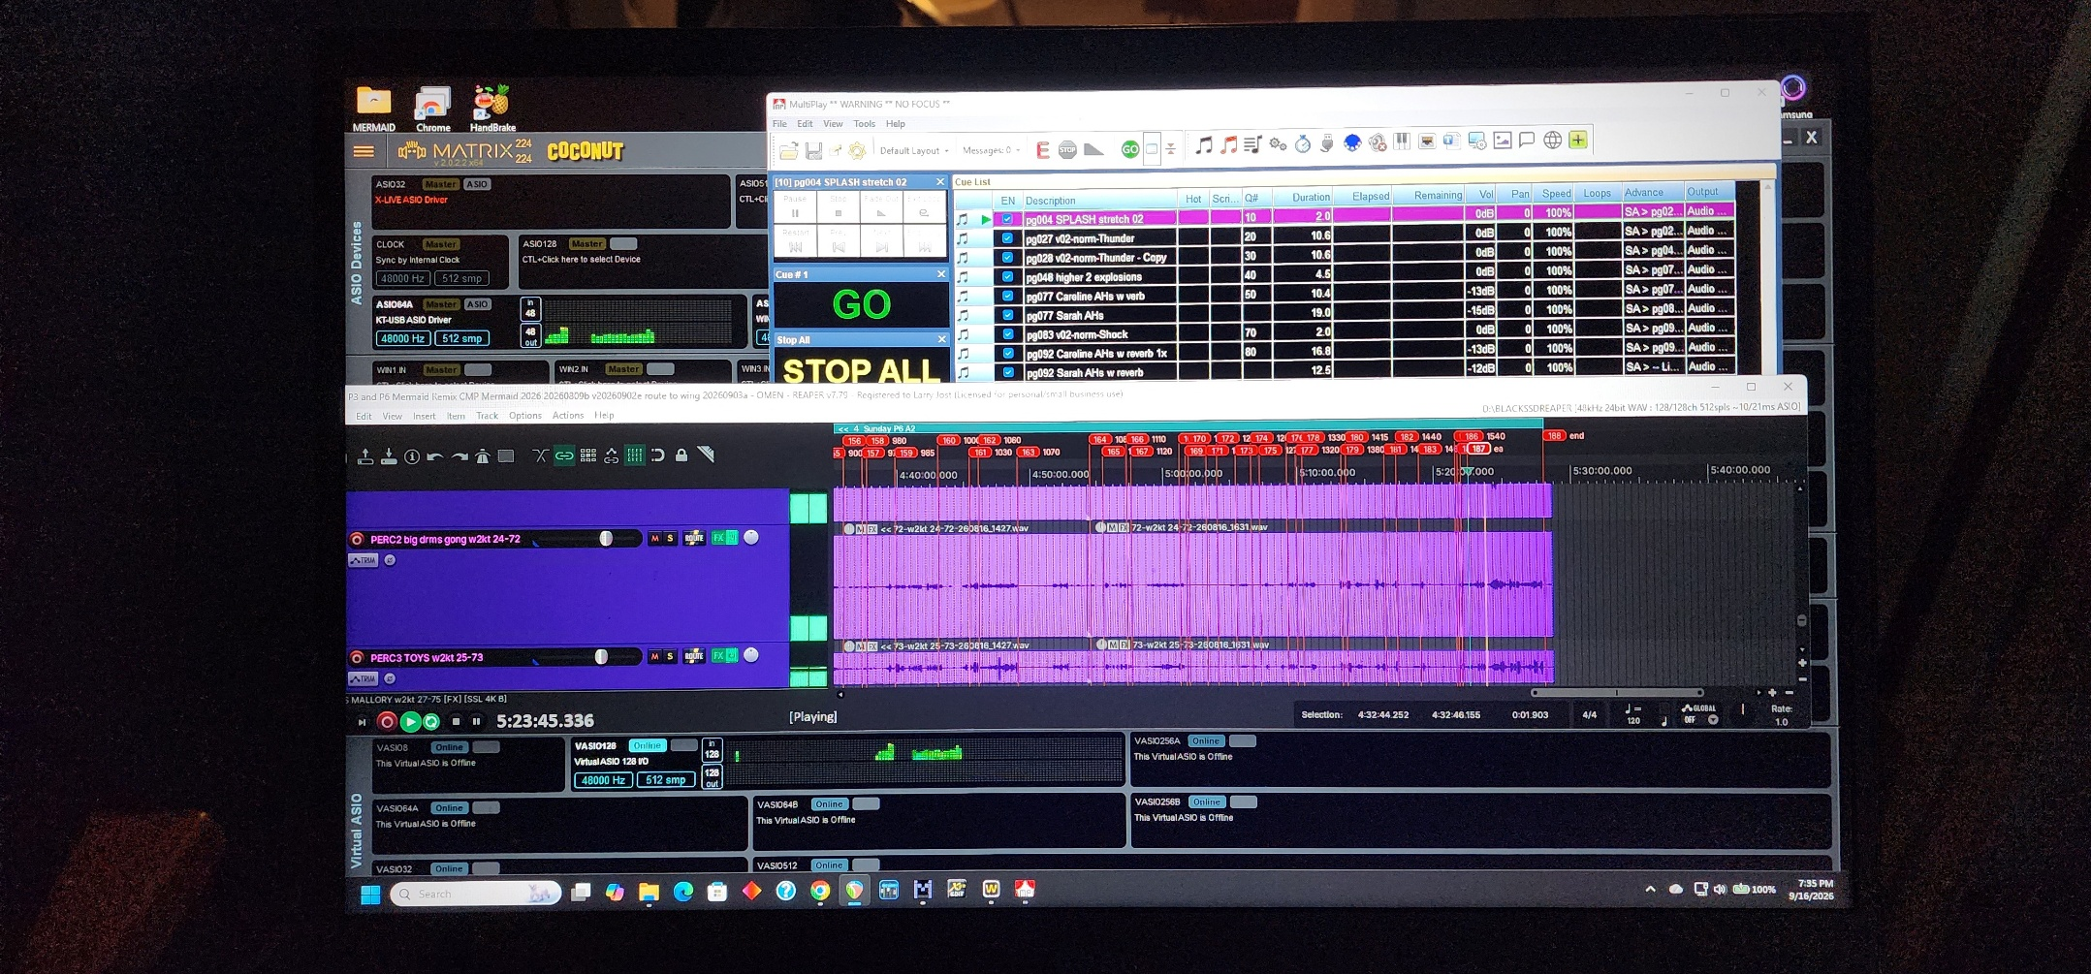
5 This shows the laptop screen of the PC that has the WING Edit sessions. MultiPlay, REAPER, and VB-Audio Matrix Coconut are running here as well.
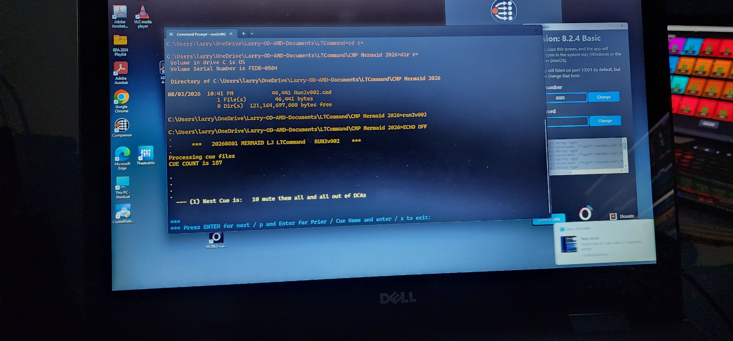
6 The CUE system script, Companion, and Vicreo Listener run here.
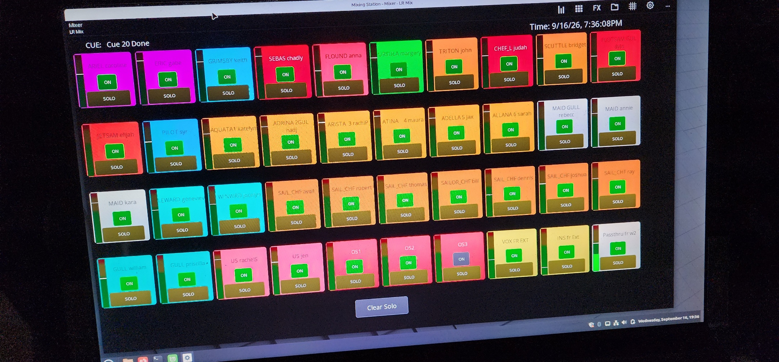
7 This shows the remote Mixing Station view of 1 WING (WING1) where someone can turn SOLO channels remotely and also see levels. This can be used by a mic tech to isolate problems and test repairs.
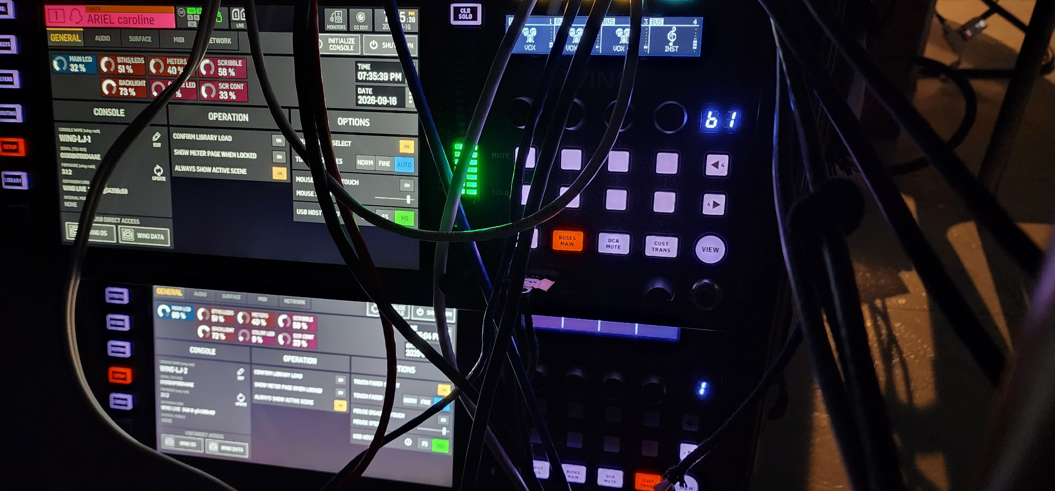
8 This is simply the 2 WING racks.

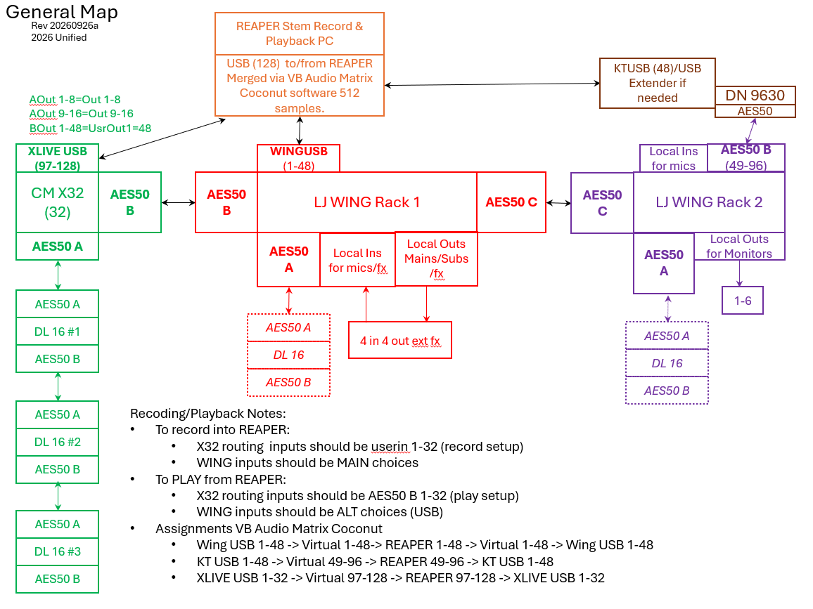
9 This shows how the 2 WING racks are connected, how they connect to REAPER, and how additional stage boxes can connect. It also shows an X32 connected for an optional placement into an existing installation without disrupting that existing input and output wiring.
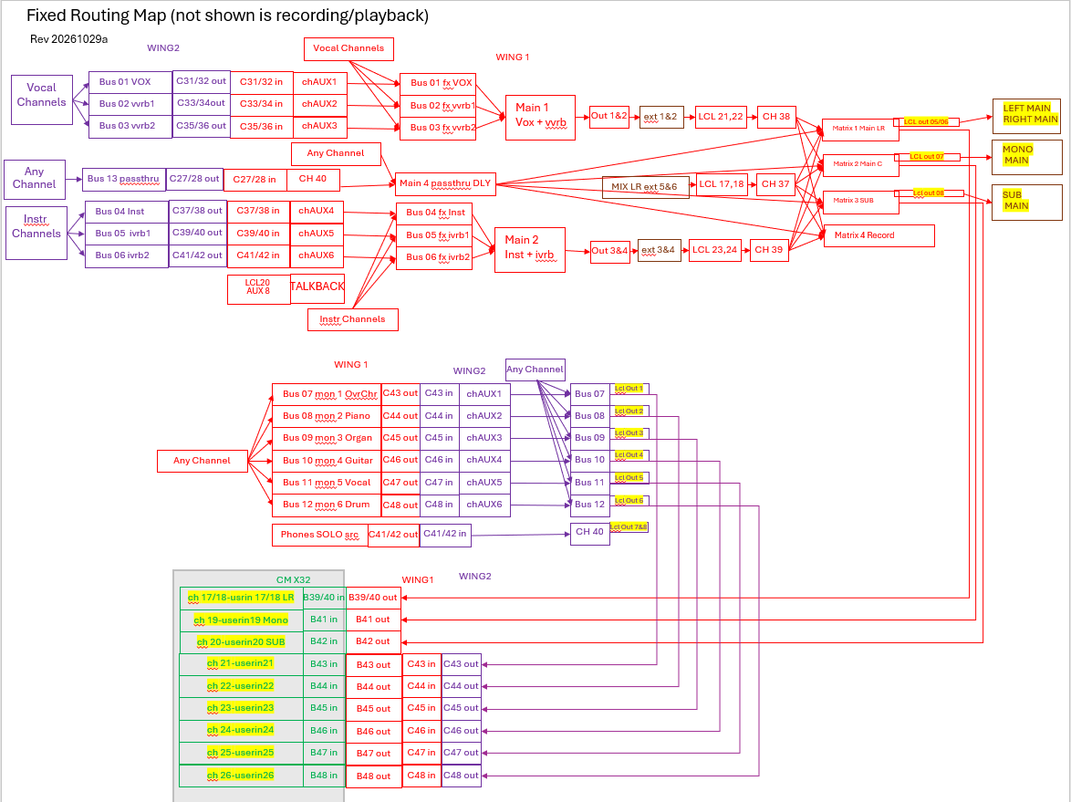
10 This shows the routing and configuration of the 2 WINGs (and in gray the optional additional X32). The 6 monitors and various outputs are shown along with how the audio flows between WINGs for cohesive processing.

